English Language Arts
ZOOM

conferencing

Check your sound and video.
As you join the Zoom each day, be sure to check your video and sound. I LOVE getting to see and hear from you.

Come prepared.
I am looking forward to our time together each day. By having all materials in close proximity, it will make our instructional time together the most productive.

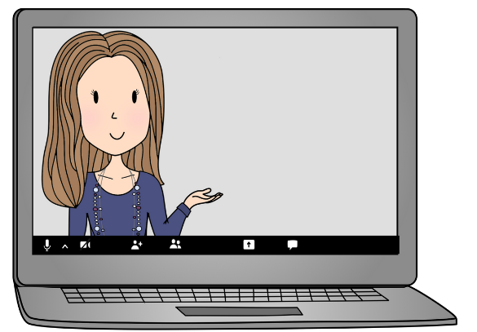
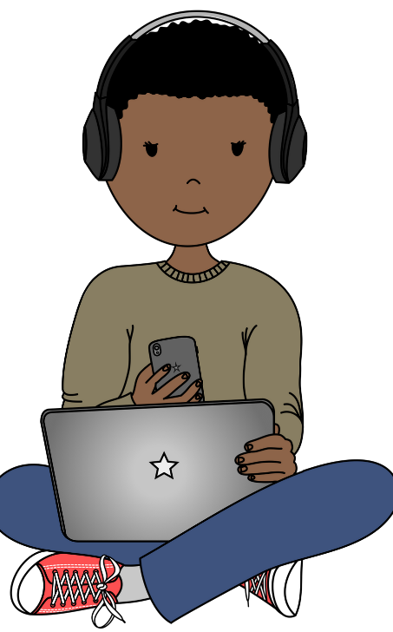
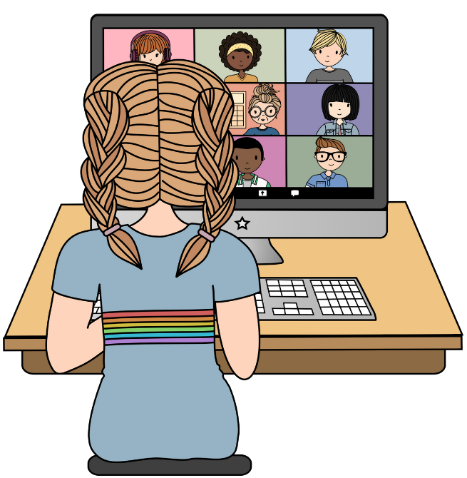
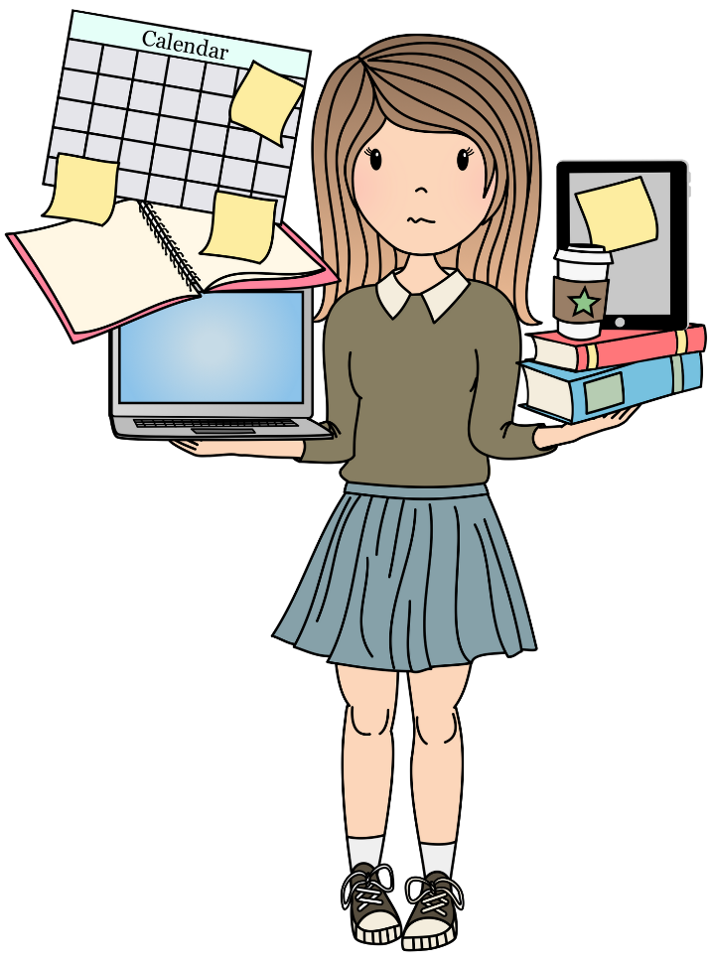

Raise your hand and use the chat to participate.
Mute your mic.
When you are not speaking, mute your mic. This helps minimize background noise.
If you have a question, use the raise hand feature or post your question in the chat.

Be accountable for your learning.

Find a space that allows you to focus.
I want to make sure that your instructional time is as purposeful and effective as possible. Find a learning space that allows you to be your best as a learner.
Keeping up with work expectations and assignment completion is essential as a student.

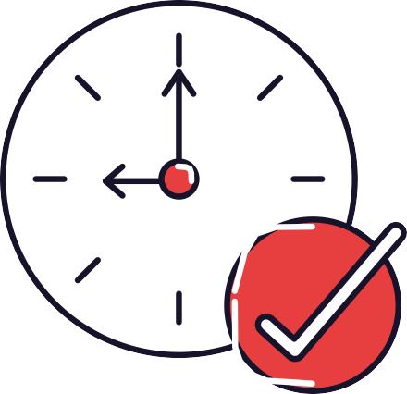
Advocate for yourself.

Be on time.
In Schoology, you will see each of the scheduled Zoom conferencing times. Being timely allows for us to maximize our learning time together.
If there is something that you need, please let me know. I am here to help you in any way that I can to ensure your success.

MrsBeers.com

